WALLKILL VALLEY YOUTH WRESTLING CLUB REGISTRATION
2021 - 2022
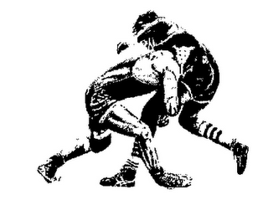
SIGN UPS FOR GRADES 2nd THROUGH 8th

• Our program was developed to provide a healthy environment for local kids to learn and appreciate a few fundamentals of wrestling.
• All boys/girls in 2nd to 8th grade from Hardyston, Hamburg, Franklin and Ogdensburg are eligible to participate
• Our Group 1 clinic is for younger and inexperienced wrestlers. Group 1 practice sessions are 1 hour sessions held on Tuesday & Thursday evenings from 5:30pm-6:30pm. They will begin on November 9th and run through February
Our Group 2 clinic is for experienced wrestlers in 2nd-8th grade. Group 2 practice sessions are Tuesday and Thursday from 5:30-7:00pm. They will begin on November 9th and run through February
• Practices will be at Touro MMA, 2741 NJ-23S Stockholm,NJ
• Group 1 wrestlers will have several optional novice tournament to practice their skills against kids of the same age and weight. Group 2 Wrestlers will be wrestling team matches against other local wrestling programs and participate in a few tournaments throughout the season
• For questions about the program, please contact Glenn Garofano at:
wallkillwrestling@gmail.com 0r (973)219-1319
• Program fee includes a Wallkill Valley Wrestling sweatshirt, shorts and insurance
• Singlets will be provided to each wrestler
• Each child must have wrestling head gear and wrestling shoes

Registration Fee-$175.00 first child / $150.00 each additional sibling
We are offering optional fight shorts and compression shirts instead of competing in the traditional singlet at an additional cost.
(you will get to keep these at end of season)
Fee: $200

To register online go to:

www.wallkillwrestling.com

